Data Flow Diagram (DFD) — Level 0, 1 & 2
Inside Hunters SFC Submission Document
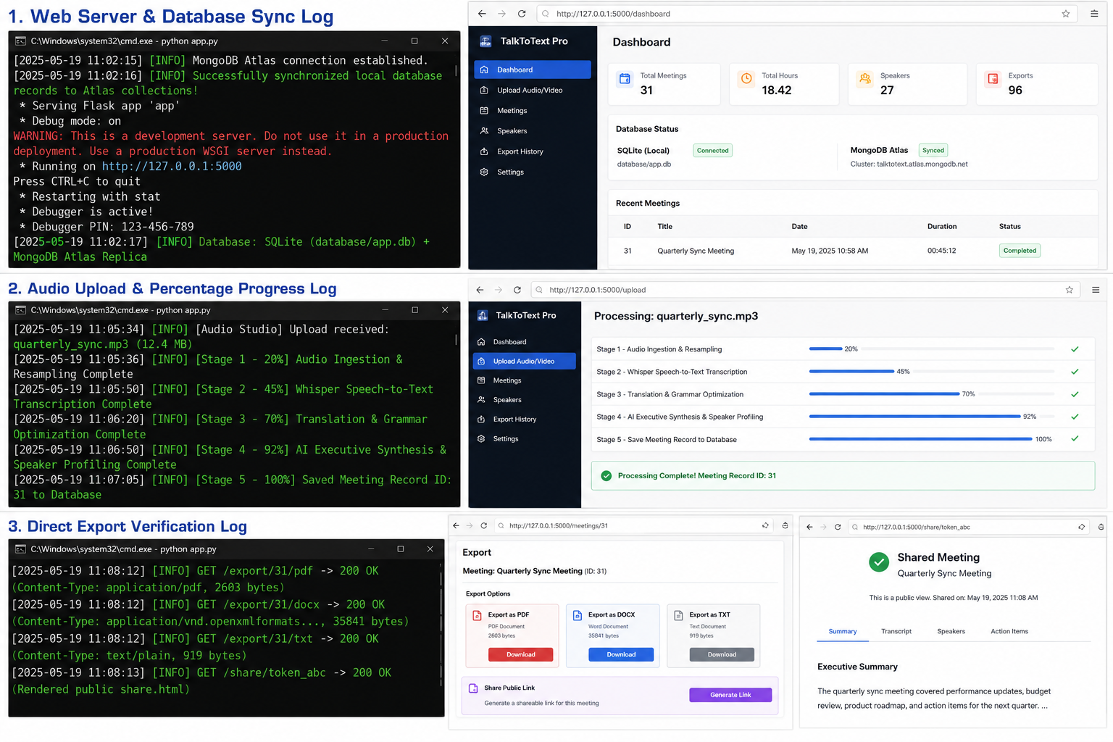

1. Level 0 Context DFD
The User interacts with the TalkToText Pro Client. Audio/Video files and voice prompts flow into the system, and structured transcripts, executive summaries, decisions, and action items flow back to the user.

2. Level 1 Functional DFD
Process 1.0 (Audio Ingestion & Resampling) -> Process 2.0 (Whisper ASR Speech-to-Text) -> Process 3.0 (LLM Synthesis & Sentiment Profiling) -> Process 4.0 (Database Persistence & MongoDB Cloud Sync) -> Process 5.0 (Multi-Format Document Export).

3. Level 2 Detailed Diarization & Chat Pipeline
Insidebot Retrieval-Augmented Generation (RAG) queries SQLite database transcripts, augments user context, and streams citations.

